***NAAN MUDHALVAN PROJECT SUBMITTION***

### *(SERVICE NOW)*

### *Category :* ServiceNow System Administrator

### *TITLE: O*ptimizing User, Group, and Role Management with Access Control and Workflows.

### COLLEGE CODE : Unm110,

### COLLEGE : Dharmamurthi Rao Bahadur Calavala Cunnan Chetty's Hindu College, pattabiram, Chennai -72.

### Team ID : NM2025TMID18320

### Team Size : 4

### Team Leader : MOHANAPRIYA P

### Team members :

### PRITHI V

### MANJULA M

### SRAVYA C

### *Project Description:*

### This project focuses on creating a structured system for user, group, and role management within a small project team. Currently, the lack of clarity in assigning responsibilities and tracking progress often leads to confusion.

### *The system introduces the following key elements:*

### *Users* – Individuals involved in the project (e.g., Alice, Bob).

### *Groups* – Categories or teams that bring users together for better coordination.

### *Roles* – Specific duties or permissions given to each user (e.g., Project Manager, Team Member).

### *Access Control* – Clear rules that define who can create, edit, or monitor project details.

### *Workflow* – A step-by-step process for assigning, monitoring, and completing tasks in an organized manner.

### *Example*: Alice, as the Project Manager, can assign tasks and oversee progress, while Bob, as a Team Member, can update his work status and mark tasks as finished.

### *By implementing this system, the project team will gain:*

### Clear accountability

### Better collaboration

### Transparent task tracking

### Improved efficiency

### In short, the system ensures smooth teamwork and effective progress monitoring.

### *****1. Users*****

Users are the people who are part of the project.

* **Example**: Alice (Project Manager) and Bob (Team Member).  
  Each user has their own account to log in, see tasks, and update progress.

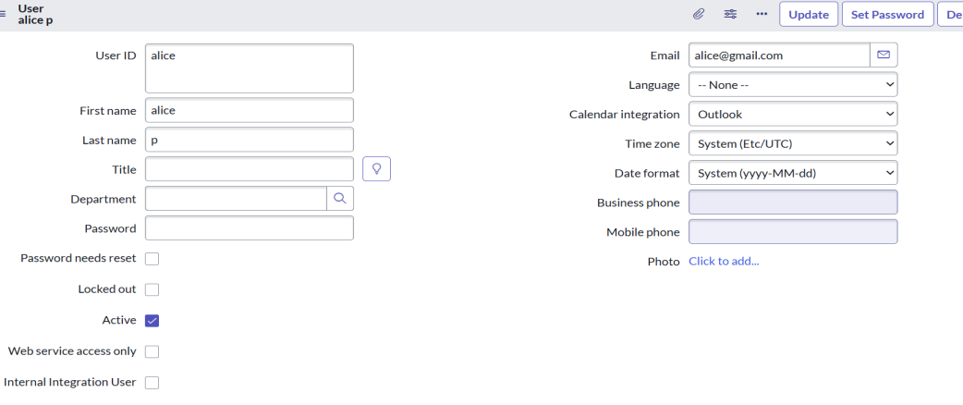

Other user:

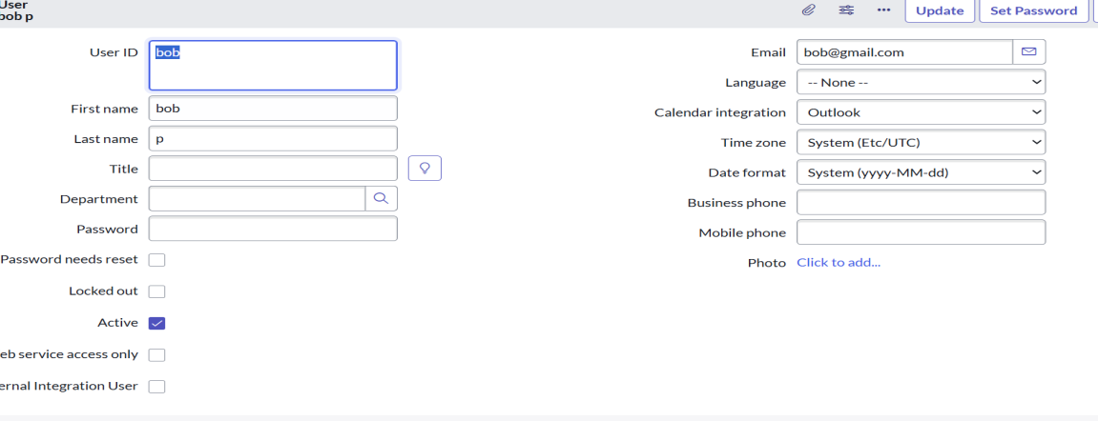

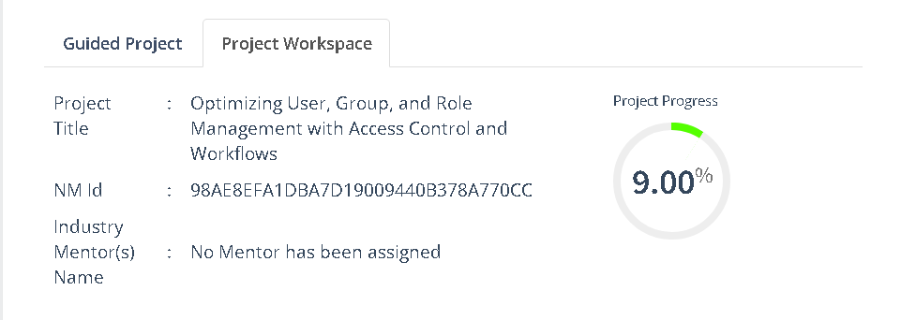

### *2.* *****Create Groups*****

* Open **ServiceNow**.
* In the left menu, click on **All** and search for **Groups**.
* Under **System Security**, select **Groups**.
* Click on **New** to create a new group.
* Fill in the required details for the group (e.g., Group Name, Description).
* Click **Submit** to save the group.

**Example Groups:**

* **Project Managers** – for people who manage tasks and track progress.
* **Team Members** – for people who work on assigned tasks.

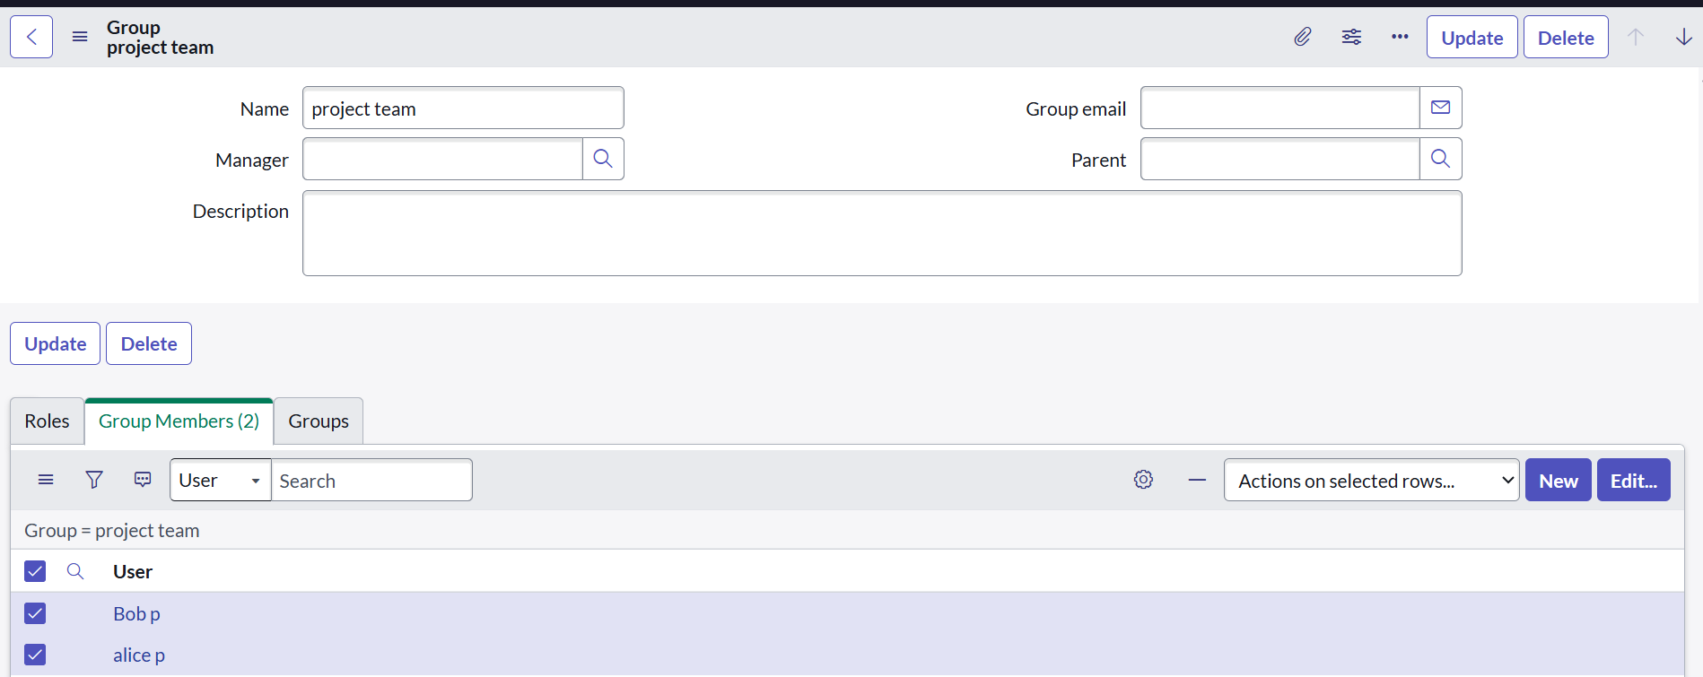

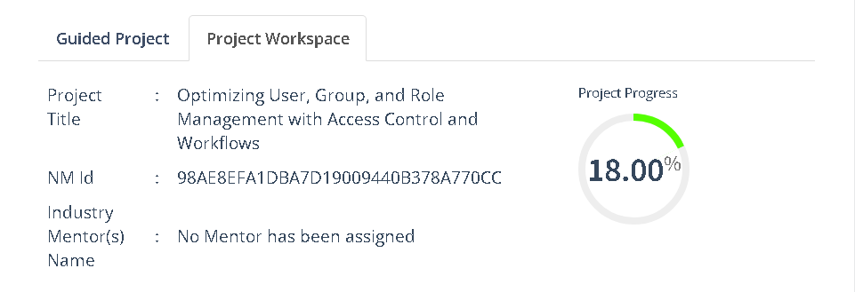

### *****3.Create Roles*****

* Open **ServiceNow**.
* In the left menu, click on **All** and search for **Roles**.
* Under **System Security**, select **Roles**.
* Click on **New** to create a new role.
* Fill in the required details for the role (e.g., Role Name, Description).
* Click **Submit** to save the role.

**Example Roles:**

* **Project Manager Role** – can assign tasks, track progress, and manage the project.
* **Team Member Role** – can view assigned tasks, update status, and complete work.

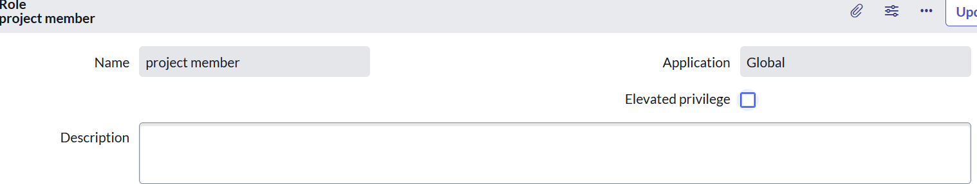

Other Role :

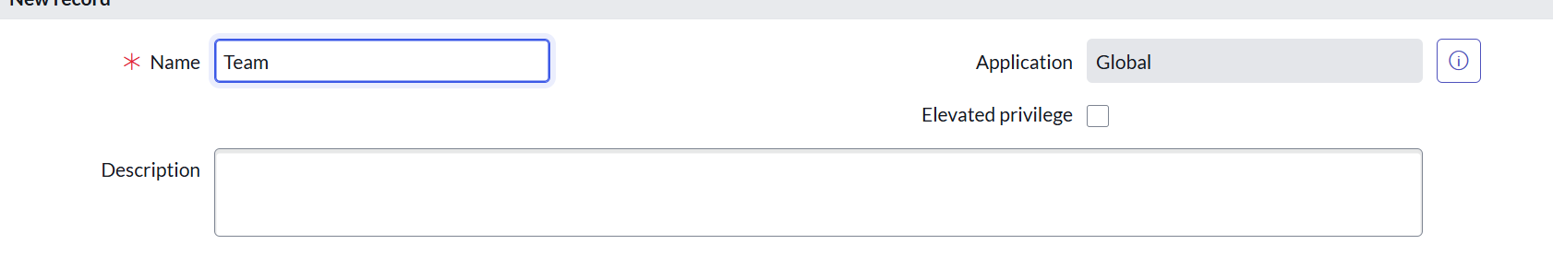

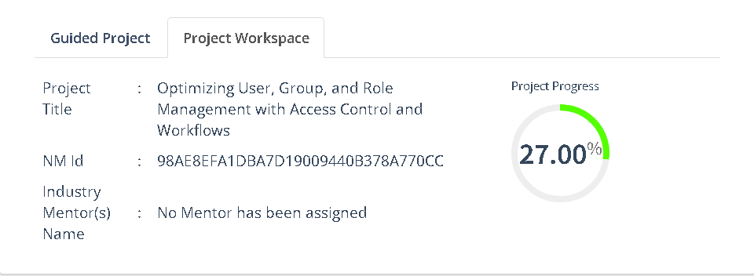

### *****4.Create Table*****

* Open **ServiceNow**.
* In the left menu, click on **All** and search for **Tables**.
* Under **System Definition**, select **Tables**.
* Click on **New** to create a new table.
* Enter the required details for the table, such as:
  + **Label** (name of the table, e.g., Project Tasks)
  + **Name** (auto-generated based on the label)
  + **Application** (select the application where the table belongs)
* Add fields (columns) to store information, such as:
  + **Task Name**
  + **Assigned To**
  + **Status**
  + **Due Date**
* Click **Submit** to save the new table.

**Example Table:**

* **Table Name:** team members

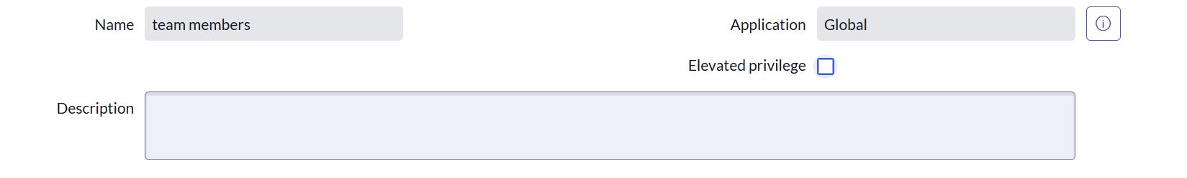

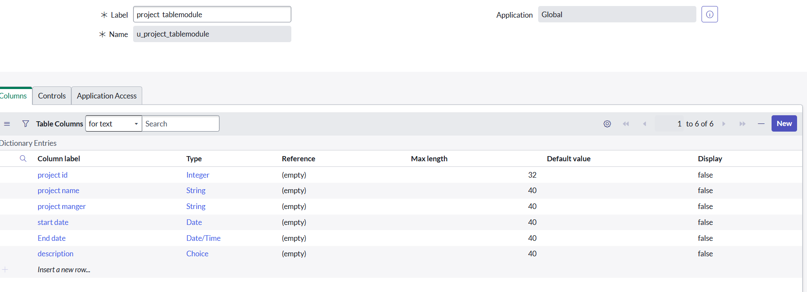

### 

### **.5. Assign Users to Groups**

* Open **ServiceNow**.
* In the left menu, click on **All** and search for **Groups**.
* Under **System Security**, select **Groups**.
* Open the group where you want to add users.
* In the **Group Members** section, click **Edit**.
* Select the users you want to add to this group.
* Click the **Add →** button to move them into the group.
* Click **Save** or **Update** to confirm.

**Example Assignment:**

* Add **Alice** to the **Project Managers** group.
* Add **Bob** to the **Team Members** group.



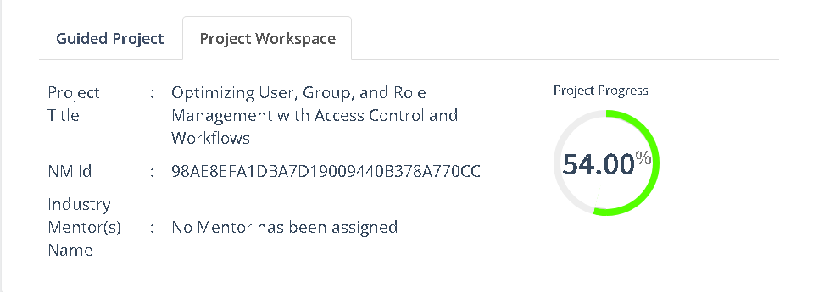

### *6.* *****Assign Roles to Alice (Project Manager)*****

* Open **ServiceNow**.
* In the left menu, click on **All** and search for **Users**.
* Under **System Security**, select **Users**.
* Find and open the record for **Alice**.
* Scroll down to the **Roles** tab.
* Click **Edit**.
* From the list of available roles, select **Project Manager Role**.
* Click the **Add →** button to move it into Alice’s assigned roles.
* Click **Save** or **Update** to confirm.

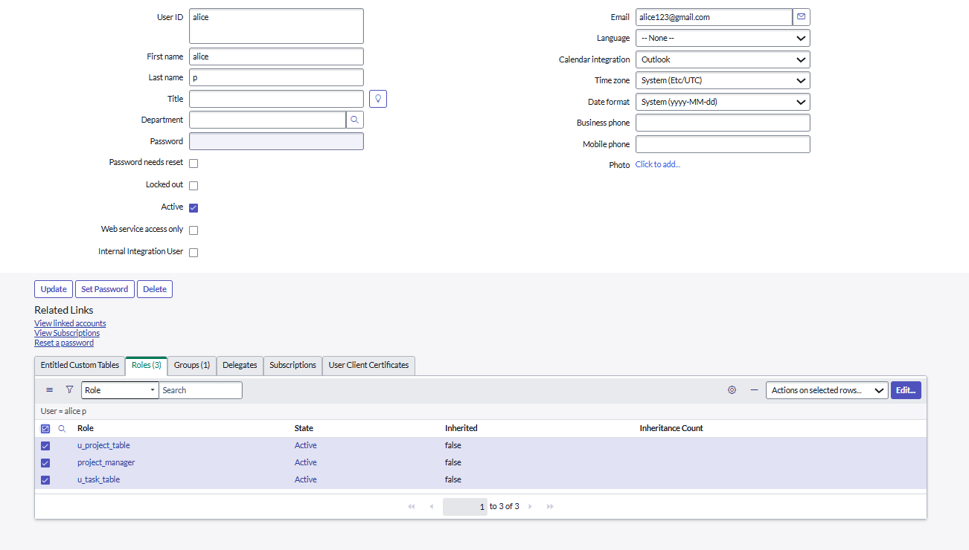

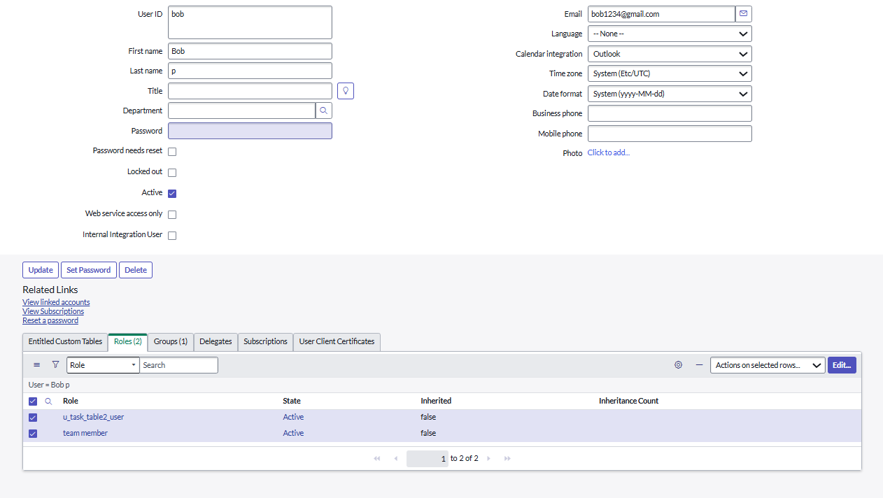

### *****7.Assign Table Access to Application*****

* When you create a new table in ServiceNow, the system automatically creates an **Application** and a **Module** for that table.
* Open the **Application Navigator** and search for your project table application (e.g., Project Table).
* Click on **Edit Module**.
* Assign the **Project Member Role** to this application so only project members can access it.
* Next, search for **Task Table 2** in the Application Navigator.
* Click on **Edit Application**.
* Assign both the **Project Member Role** and the **Team Member Role** to this application.

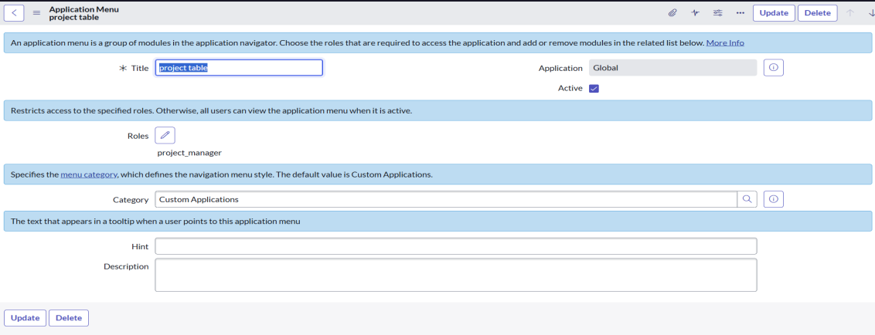

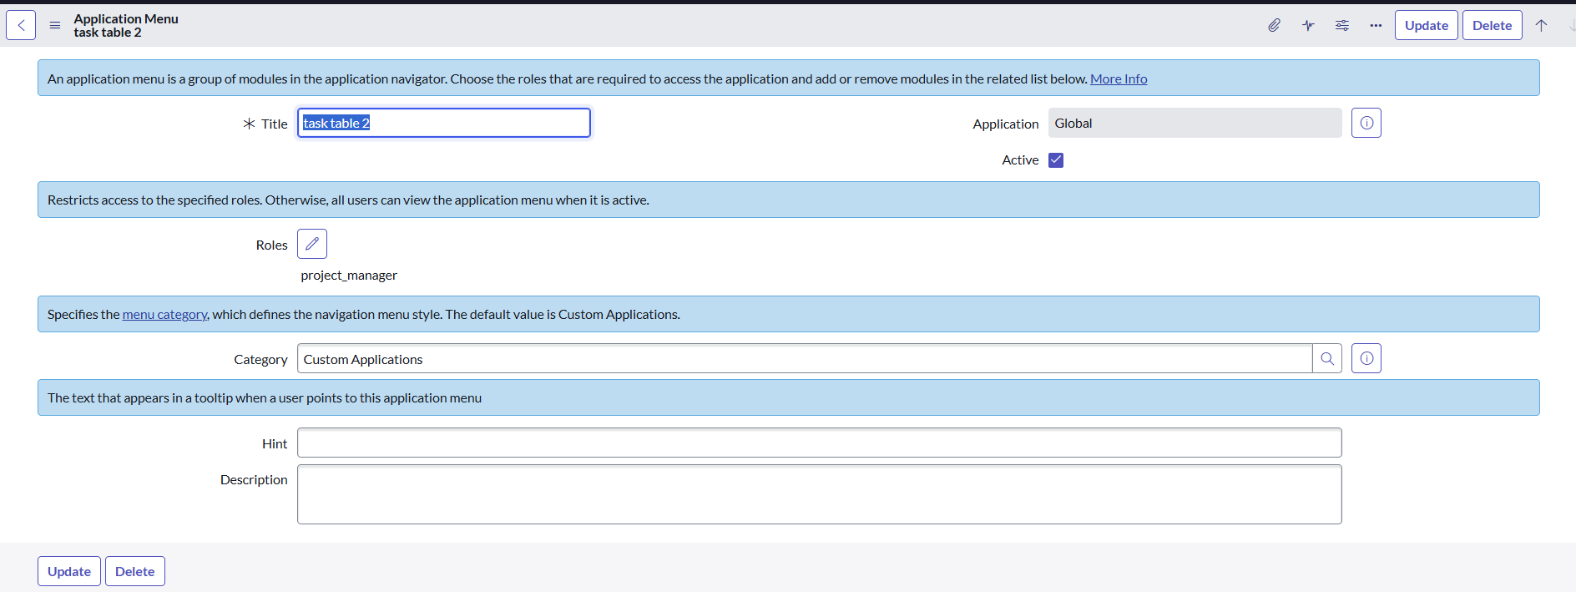

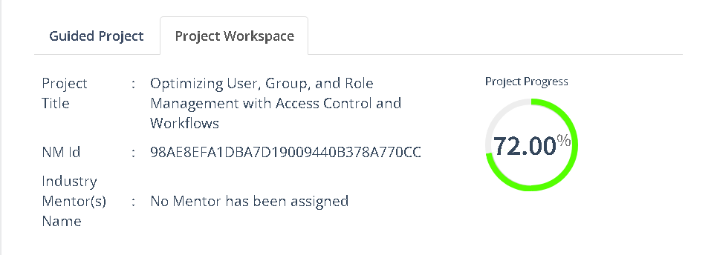

### *****8.Create ACL (Access Control List)*****

* Open **ServiceNow**.
* In the left menu, click on **All** and search for **ACL**.
* Under **System Security**, select **Access Control (ACL)**.
* Click on **Elevate Role** (to get admin access for creating ACLs).
* Click on **New** to create a new ACL.
* Fill in the details for the ACL, such as:
  1. **Table/Field** (what you want to control access to)
  2. **Operation** (read, write, create, delete)
  3. **Roles** (who should have access)
* Click **Submit** to save the ACL.
* 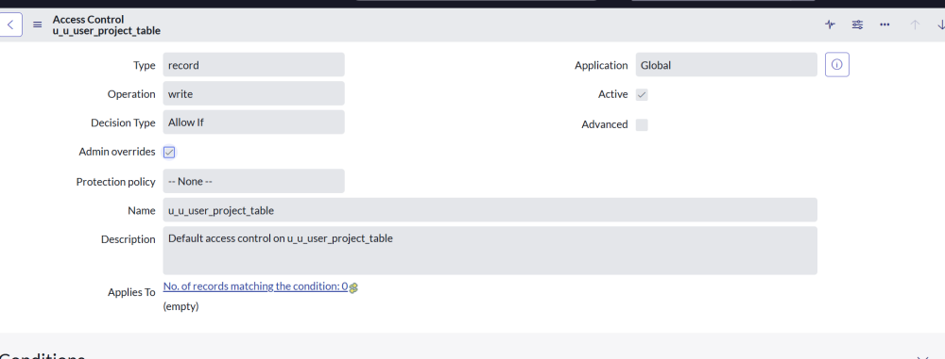

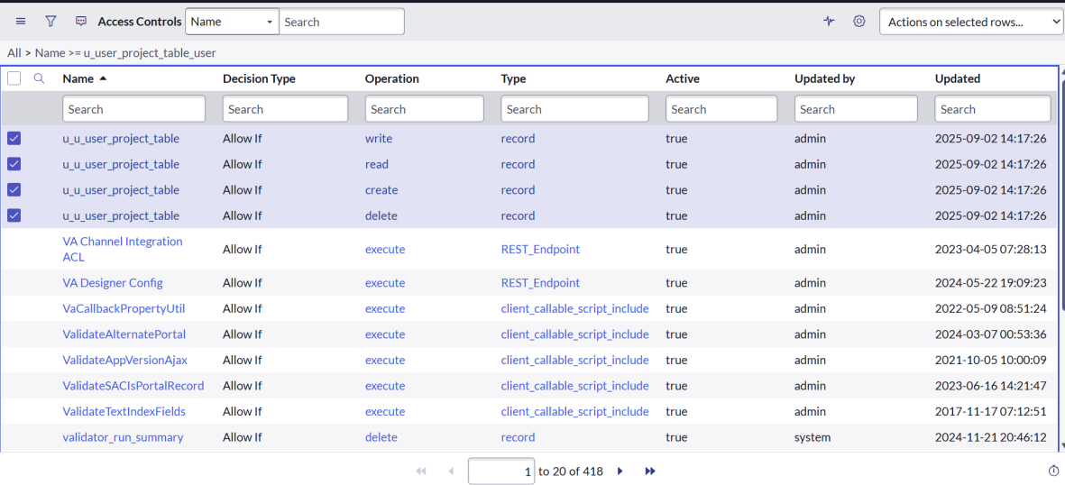

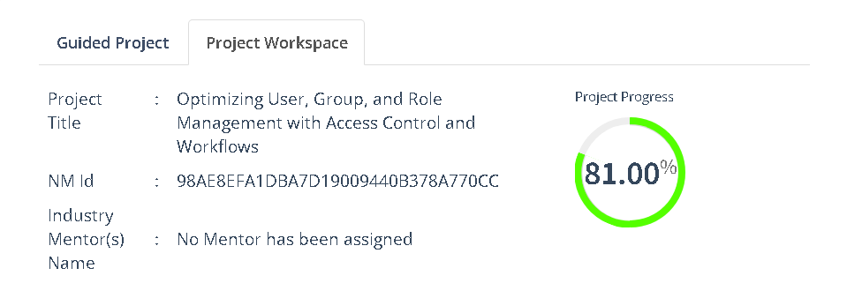

### *9.* *****Create a Flow to Assign Operations Ticket to Group*****

1. Open **ServiceNow**.
2. In the left menu, click on **All** and search for **Flow Designer**.
3. Open **Flow Designer** under **Process Automation**.
4. Click **New** → select **Flow**.
5. Fill in the flow details:
   * **Flow Name:** task table
   * **Application:** Global
6. Click **Build Flow**.

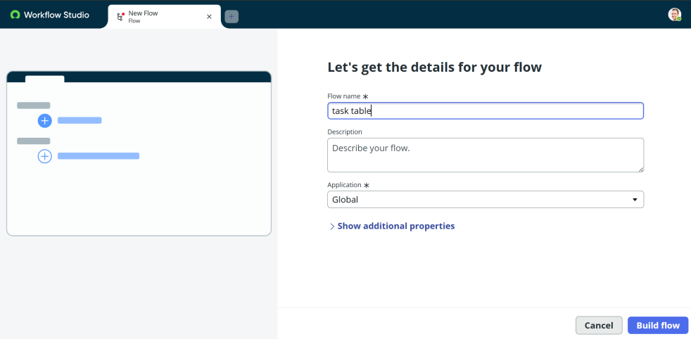

### **Add a Trigger**

1. Click on **Add a Trigger**.
2. Search for **Create Record** and select it.
3. Choose **Table Name:** task table.
4. Add conditions:
   * **Status** → is → In Progress
   * **Comments** → is → Feedback
   * **Assigned To** → is → Bob
5. Click **Done**.

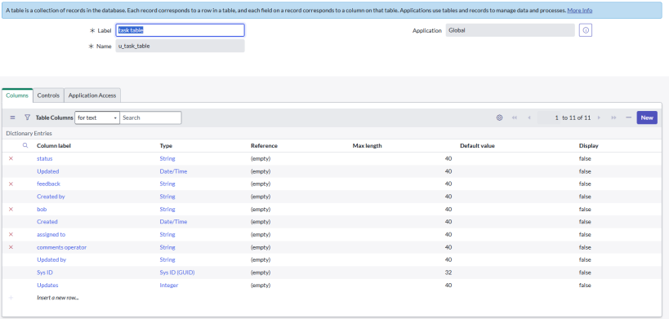

### **Add Actions**

1. Click **Add an Action**.
2. Search for **Update Records**.
3. Drag fields from the **Data Pill** (right side) into the record field.
4. Table will auto-fill.
5. Add this field:
   * **Status = Completed**
6. Click **Done**.

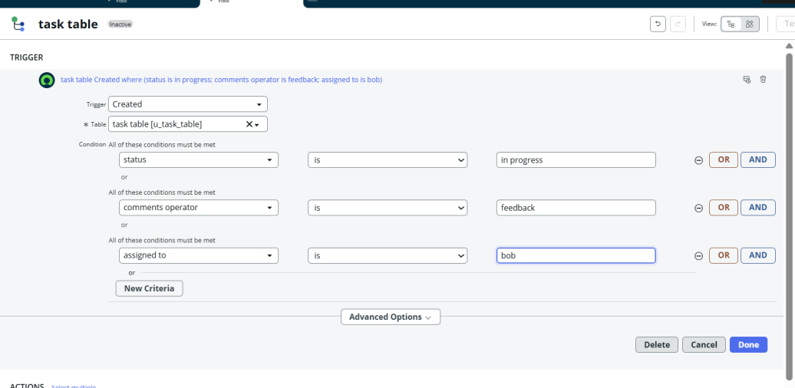

### **Add Approval Step**

1. Under **Actions**, click **Add an Action**.
2. Search for **Ask for Approval**.
3. Drag the record fields from the **Data Pill**.
4. Table will auto-fill.
5. Fill details:
   * **Approval Field:** Status
   * **Approver:** Alice P
6. Click **Done**.

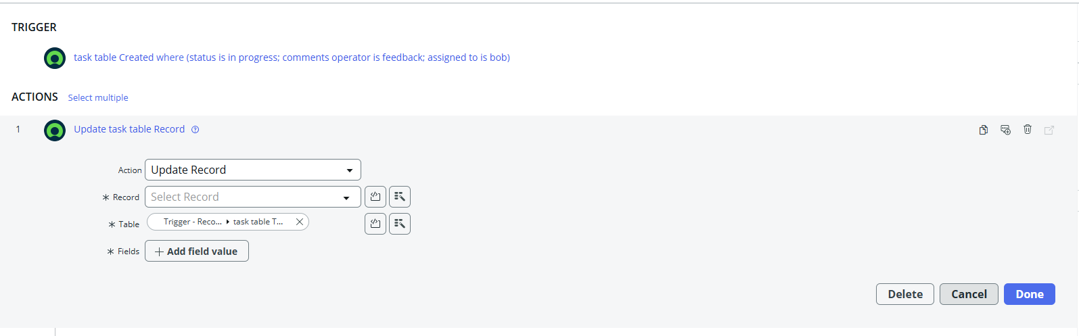

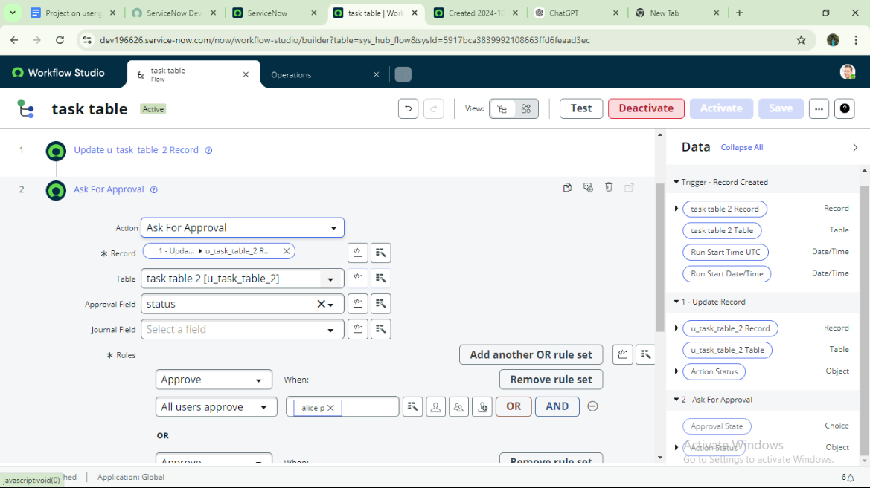

### **Test the Flow**

1. In the **Application Navigator**, search for **Task Table**.
2. Check that the **Status** field updates to **Completed** when conditions match.
3. Then go to **My Approvals** under the **Service Desk**.
4. Alice P will see the approval request.
5. Right-click the request → select **Approve**.

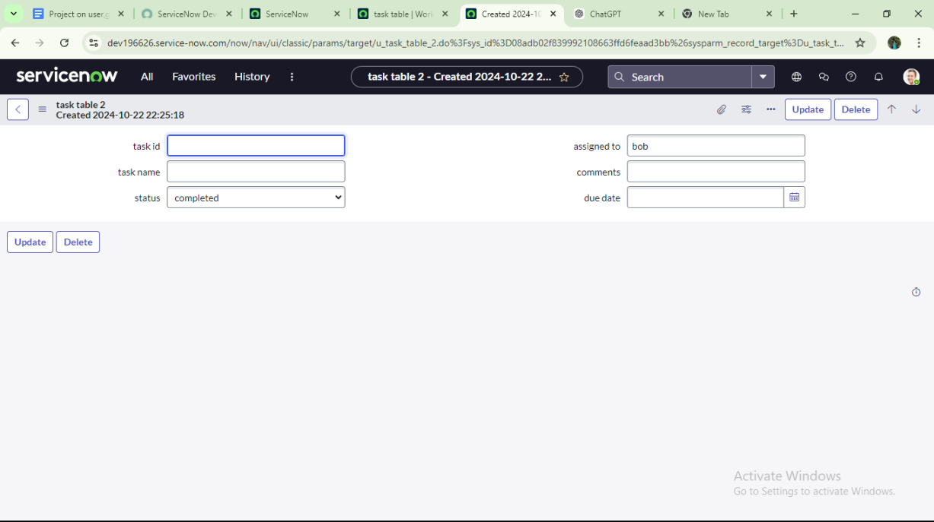

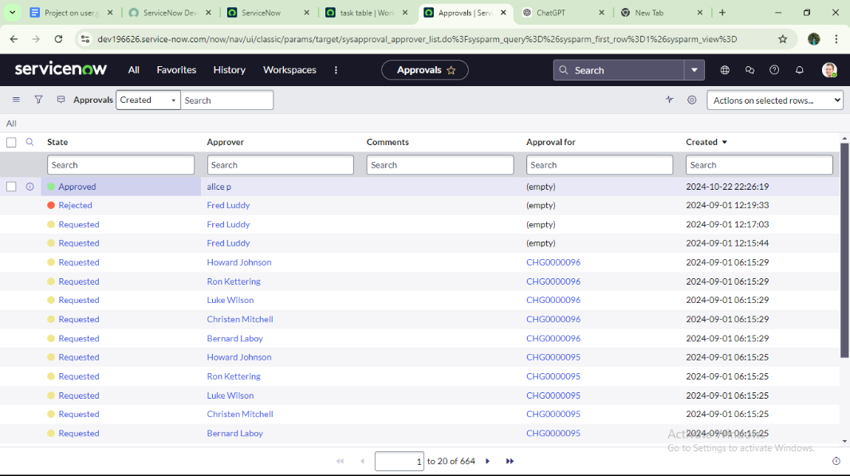

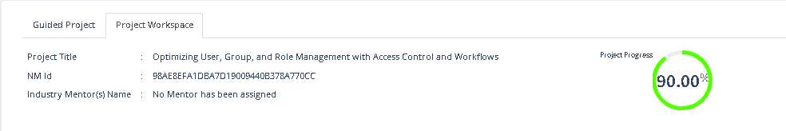

**Conclusion:**

**This project highlights the importance of a structured approach to project management through clearly defined roles and responsibilities. With Alice handling oversight as the Project Manager and Bob focusing on execution as a Team Member, the system ensures both accountability and efficiency. The use of tables and organized workflows makes it easier to track tasks, monitor progress, and maintain transparency. By improving communication and fostering collaboration, this framework creates a balanced environment that supports smooth operations and leads projects toward successful and timely completion.**